

**Faculty of Engineering and Technology Electrical and Computer Engineering Department**

**DIGITAL ELECTRONICS AND COMPUTER ORGANIZATION LABORATORY ENCS2110**

**Experiment No. 4,6**

**4: Digital Circuits Implementation using Breadboard**

**6: Sequential Logic Circuits using Breadboard and IC’s**

**Prepared by:**

**Layal Abed 1221480**

**Partners:**

**Rema Qashoo 1221009**

**Aya Abu Sneineh 1221414**

**Instructor: Abualseoud Hanani**

**Teaching assistant:Hanan**

**Section : 2**

**Date: 12-8-2024**

Abstract

In this experiment we will study circuit design In addition, we will pay particular attention to the importance of integrated circuits (IC's) and understand how we can use them to build circuits. This will be done by learning how to use a breadboard and taking a hands-on approach in implementing different circuits like Decoder and. BCD-to-seven-segment decoder.

**Table of Contents**

Abstract II

Table of Figures IV

Table of Table V

1.Theory for Experiment - 1 -

1.1 74xx ICs Family: - 1 -

1.1.1 IC’s: - 1 -

1.1.2 IC 74xx Family - 2 -

1.2 Breadboard: - 3 -

1.3 2-to-4 line binary decoder : - 3 -

1.4 seven-segment display - 4 -

1.5 BCD-to-seven-segment decoder: - 5 -

1.6 Counter : - 6 -

2. Procedure and Discussion: - 7 -

2.1 constructing Decoding : - 8 -

2.1.1 1connection: - 8 -

2.1.2 Results : - 9 -

2.1.3 Discussion: - 9 -

2.2 BCD Counter from 0 to 9 : - 10 -

2.2.1 1connection: - 10 -

2.2.2 Ruselt : - 12 -

2.2.3 Discussion: - 12 -

Conclusion : - 13 -

References: - 14 -

Table of Figures

Figure 1 : IC Source: builder.id) Figure 2 :Numbered IC(Source: innovation gallery) - 1 -

Figure 3 :DIGITAL GATES IN IC PACKAGES - 2 -

Figure 4 :breadboard. Lines indicate connected holes - 3 -

Figure 5 :2-to-4 line binary decoder - 3 -

Figure 6 :common anode/cathode displays. - 4 -

Figure 7 :implement BCD-to-seven-segment decoder from basic gates - 5 -

Figure 8 :Figure 8:7447 pin assignments - 5 -

Figure 9 :7490 counter pin assignment - 6 -

Figure 10 :Decoder Implementation using basic gates - 8 -

Figure 11 : :Implementation of Decoder (Source: Our Work) - 9 -

Figure 12 : display-decoder connection. Table 3 :BCD-to-seven-segment decoder - 10 -

Figure 13 :Implementation counter using IC's - 11 -

Figure 14 :counter using IC's 7490 LC’s)counter and 7 segment BCD decoder (7447 LC’s) - 11 -

Table of Table

Table 1 : Reset/count function table .... ....... .............. - 6 -

Table 2 Outputs of Decoder - 9 -

Table 3 :BCD-to-seven-segment decoder - 10 -

Table 4 :BCD Counter from 0 to 9 - 12 -

**1.Theory for Experiment**

1.1 74xx ICs Family:

1.1.1 IC’s:

An Integrated Circuit (IC) is a small silicon chip containing a large number of transistors and electronic components integrated to form a specific circuit. Before ICs, circuits were implemented using a method called soldering, where each component was separate, leading to large, high-power-consuming circuits that were unreliable and prone to shock. The invention of ICs revolutionized technology, advancing us from the second to the third generation of technological development look at Figure 1 When handling an IC, hold it with the notch on the left, count the pins from bottom left to right, and continue counting from right to left on the topit look like Figure 2 . [1]

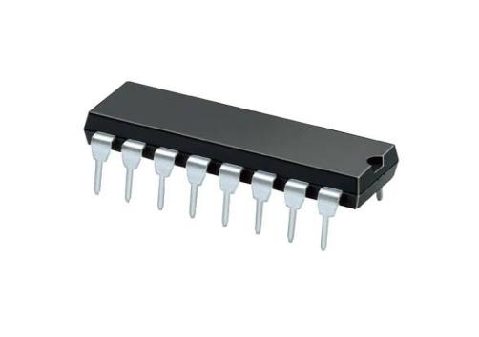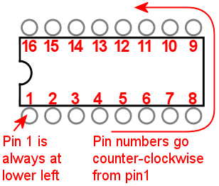

Figure 1: IC Source: builder.id) Figure 2 :Numbered IC(Source: innovation gallery)

1.1.2 IC 74xx Family

The 74xx series Integrated Circuits (ICs), developed by Texas Instruments, is a well-known family of digital logic chips commonly used in electronics. These ICs are mainly built on Transistor-Transistor Logic (TTL) technology, which operates on a 5V power supply. They are known for their fast response times, but they also consume relatively high power. The 74xx series includes different types of logic gates, each identified by a specific number that indicates the type of gate in the IC. For example, the 7400 IC contains four NAND gates. Over time, the series has grown to include newer versions like 74HC00 and 74LS00, which offer better efficiency and compatibility. Additionally, there are low-voltage versions like 74LVC and 74AUP that operate at voltages as low as 3.3V. These ICs use both bipolar and CMOS (Complementary Metal-Oxide-Semiconductor) technologies here in Figure 3: DIGITAL GATES IN IC PACKAGES.[2]

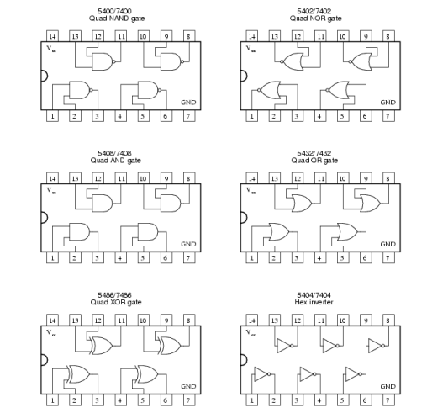

Figure 3 :DIGITAL GATES IN IC PACKAGES

1.2 Breadboard:

A breadboard is an essential tool in electronics for prototyping and testing circuits without soldering. It features a plastic board with holes arranged in rows and columns, connected internally by conductive strips. These strips create nodes where components can be inserted and connected. The breadboard typically has two types of strips: terminal strips for connecting components and bus strips for distributing power. The terminal strips, divided by a central gap, hold most components, while the bus strips are used for power and ground connections. Proper use requires understanding the layout and making accurate connections to avoid circuit faults, overheating, or damage due to incorrect voltage or polarity as show in Figure 4: The breadboard. Lines indicate connected holes.[3]

. 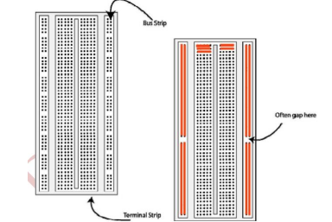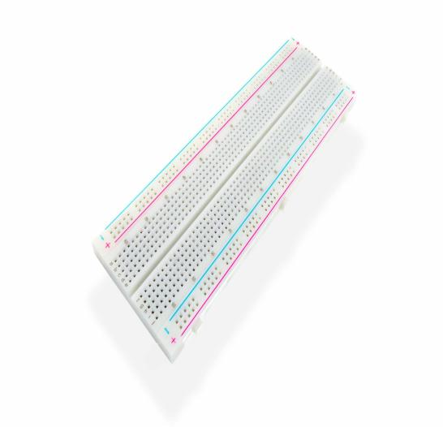

Figure 4 :breadboard. Lines indicate connected holes

1.3 2-to-4 line binary decoder :

The 2-to-4 line binary decoder consists of an array of four AND gates. It takes two binary inputs, labeled A and B, and decodes them into one of four outputs. Each output corresponds to one of the minterms of the two input variables, meaning each output is uniquely associated with a specific combination of A and B. This is why it's called a 2-to-4 binary decoder in Figure 5 : show 2-to-4 line binary decoder .[4]

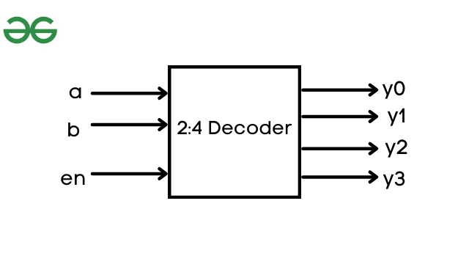

Figure 5 :2-to-4 line binary decoder

1.4 seven-segment display

The seven-segment LED display is a widely used type of display in consumer electronics such as calculators, clocks, and microwaves. It consists of seven bar-shaped LEDs that can be lit in specific combinations to display decimal digits (0-9) and some hexadecimal characters (A-F). Some displays also include an additional LED for the decimal point.

There are two types:

1.Common Anode: All LEDs share a common positive supply (+5V). To light a segment, the input must be low.

2.Common Cathode: All LEDs share a common ground (0V). To light a segment, the input must be high.

Current-limiting resistors are used in both types to control brightness and prevent damage to the LEDs. These displays effectively show numerical information in electronic devices here in Figure 6 : show the common anode/cathode displays. [5]

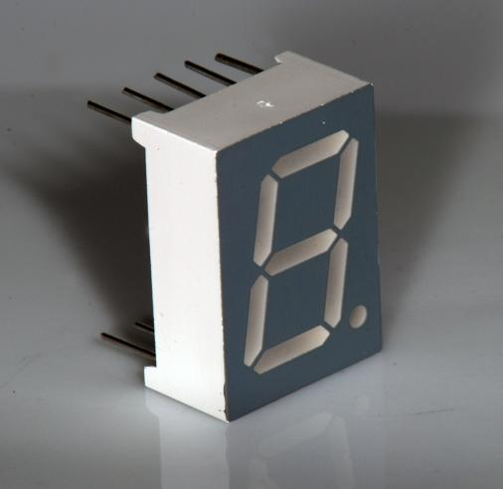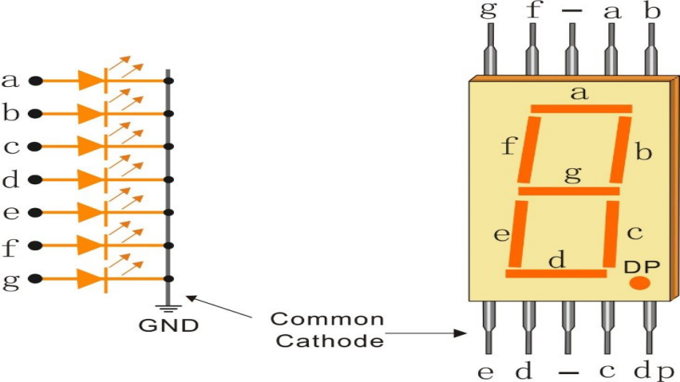

Figure 6 :common anode/cathode displays.

1.5 BCD-to-seven-segment decoder:

A BCD-to-seven-segment decoder converts Binary-Coded Decimal (BCD) inputs into signals that drive a seven-segment display. The IC type 7447 is commonly used for this purpose. It has BCD inputs (A, B, C, D), with D being the most significant bit, and outputs (a, b, c, d, e, f, g) that drive the segments of the display (active low). Additional pins include RBI (Ripple Blanking Input), which controls whether to blank a decimal zero, and BI/RBO (Blanking Input/Ripple Blanking Output), which can be used to blank the display or indicate blanking status. The LT (Lamp Test) input turns on all segments when low, useful for checking display functionality. For normal operation, LT, RBI, and BI/RBO should be connected to +5V, as these inputs are active low in Figure 12 :show 7447 pin assignments and in Figure 7 : implement BCD-to-seven-segment decoder from basic gates and Figure 8 is : BCD-to-seven-segment decoder in LC’s. [6]

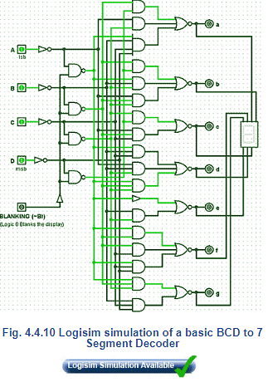

Figure 7 :implement BCD-to-seven-segment decoder from basic gates

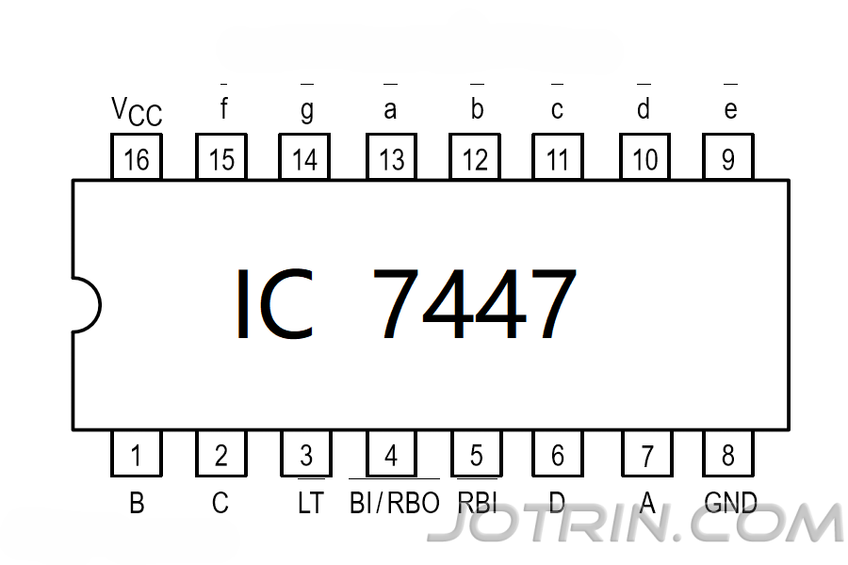

Figure 8 :Figure 8:7447 pin assignments

1.6 Counter :

In this lab the IC type 7490 counter will be used. The 7490-pin assignment is shown in Figure 9 and reset/count function table is shown in Table 1.

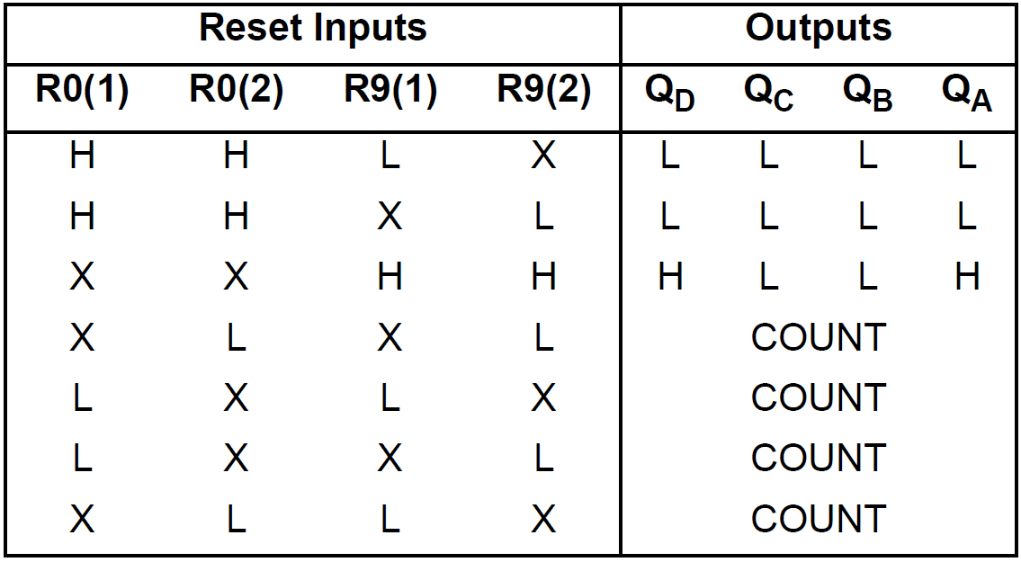

Table 1: Reset/count function table

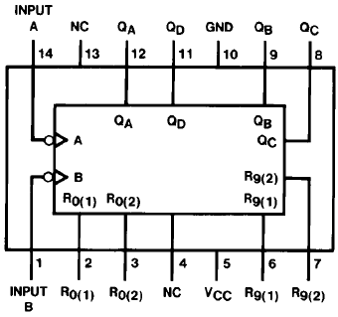

Figure 9 :: 7490 counter pin assignment

2. Procedure and Discussion:

We will use the breadboard and ICs to implement Decoder and counter from 0 to 9 , ensuring the following steps:

1. The power is off before connecting anything.

2. Power and ground are properly connected in the circuit.

3. The IC is correctly placed in the channel in the middle.

4. Connections are double-checked before turning the power on.

5. If an error is noticed, the power is quickly turned off.

6. All wires are properly placed, with none left out.

2.1 constructing Decoding :

2.1.1 1connection:

We connect the circuit as shown in the figure 10 This is done by tracking the  . Figure 10 and discussed the following points

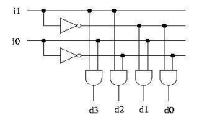

Figure 10 :Decoder Implementation using basic gates

To implement a 2x4 decoder on a breadboard, follow these steps:

1. Consult datasheets to identify the pin configurations for the AND (7408) and NOT (7404) gate ICs.

2. Place the ICs on the breadboard, ensuring proper orientation using the notch or dot.

3. Connect the Vcc and GND pins of the ICs to a 5V power source.

4. Connect inputs i0 and i1 to the NOT gates to generate inverted outputs.

5. Link these inverted outputs and the direct inputs i0 and i1 to four AND gates to produce the outputs d0, d1, d2, and d3: d0 with both inputs inverted, d1 with i0 inverted, d2 with i1 inverted, and d3 with neither inverted.

6. Attach the outputs from the AND gates to labeled points on the breadboard for d0, d1, d2, and d3.

7. Double-check all connections for accuracy.

8. Follow the circuit using the clock key and check the result by following the table 2.

9. in Figere 11 we do all this step so look at it .

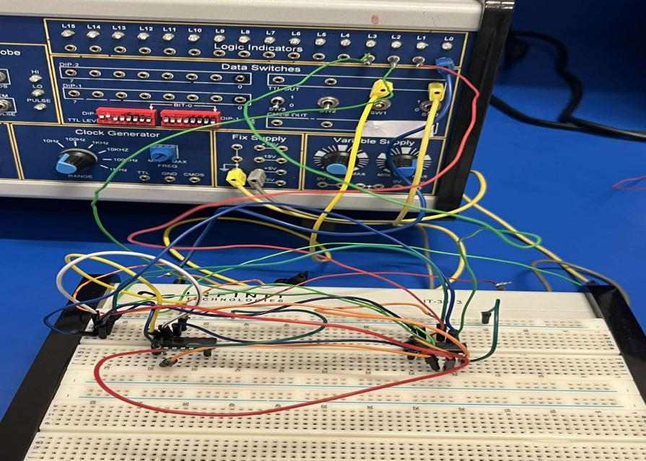

Figure 11 : :Implementation of Decoder (Source: Our Work)

2.1.2 Results :

|  |  |  |  |  |  |
| --- | --- | --- | --- | --- | --- |
| INPUTS | | OUTPUTS | | | |
| Input1 | Input2 | Output1 | Output2 | Output3 | Output4 |
| 0 | 0 | 1 | 0 | 0 | 0 |
| 0 | 1 | 0 | 1 | 0 | 0 |
| 1 | 0 | 0 | 0 | 1 | 0 |
| 1 | 1 | 0 | 0 | 0 | 1 |
|  |  |  |  |  |  |

Table 2 Outputs of Decoder

**2.1.3** Discussion:

We compared the outputs with the decoder outputs and found that the outputs were correct. Every time we pressed the clock, only one light out of 4 would light up.

2.2 BCD Counter from 0 to 9 :

2.2.1 1connection:

To implement counter do this step:

1. Testing Lamps in the Display:

- Place the 7-segment display and 7447 decoder chips on the breadboard, following the circuit in Figure 12.

- Connect pins 4 (BI) and 5 of the 7447 decoders to +5V, and ground pin 3 (LT). Ensure all 7 segments light up to verify the display's functionality You can check the result by following Table 3.

2. Blanking All Segments:

- Ground pin 4 (BI) of the decoder. Confirm that all 7 segments turn off, verifying the blanking function. Leave the circuit connected.

3. Implementing One Decade Counter:

- Connect the pre-lab circuit design to the breadboard. Get instructor/assistant approval before powering on.

- Apply clock pulses to pin 14 of the 7490 counter using the Pulser Switch (SWA) and observe the counting sequence on display D1.

- Repeat with the "pulse generator" of the IT-3000 Basic Electricity Circuit Lab, observing the count sequence again.

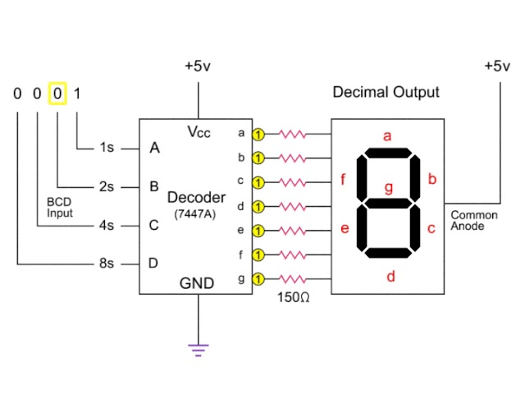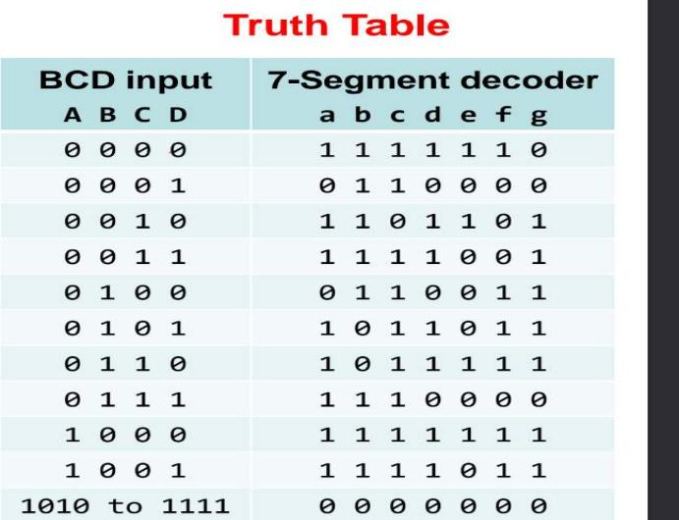

Figure 12 :display-decoder connection. Table 3 :BCD-to-seven-segment decoder

We have combined all the steps we have done in Figure 13 and when you done all this step you must get the carcit like the figure 14 look at Table 4 to show the result.

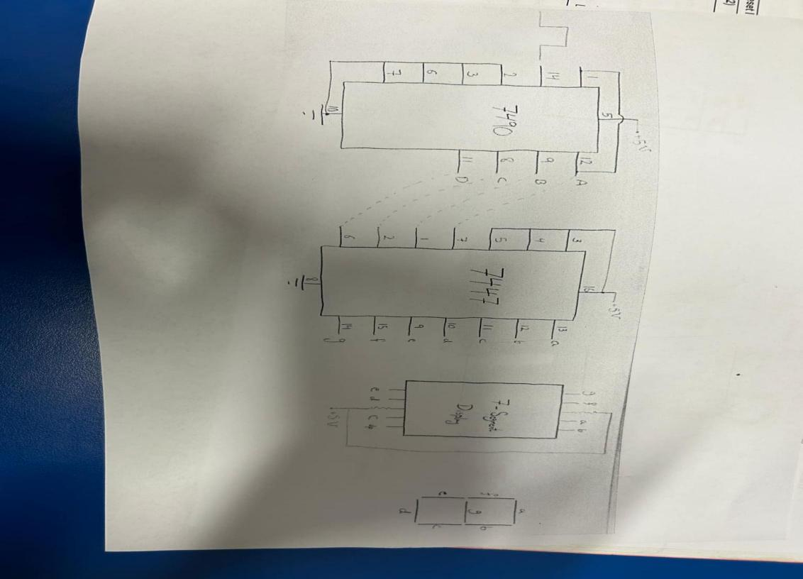 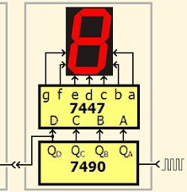

Figure 13 :Implementation counter using IC's

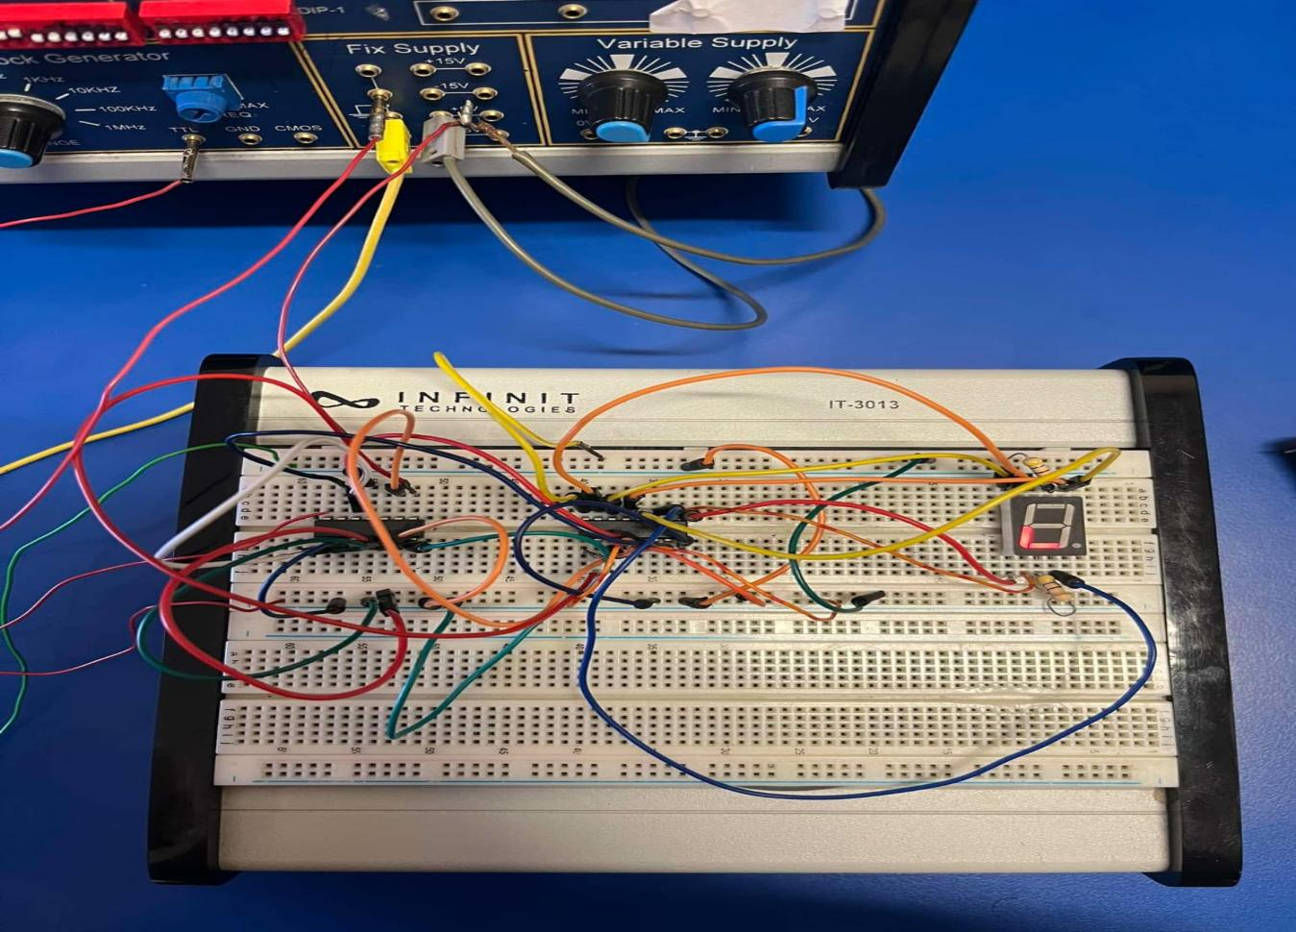

Figure 14 :counter using IC's 7490 LC’s)counter and 7 segment BCD decoder (7447 LC’s)

2.2.2 Ruselt :

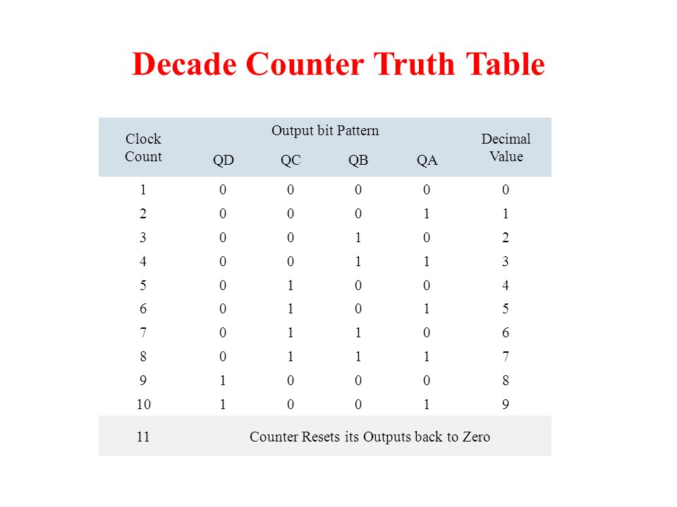

Table 4 :BCD Counter from 0 to 9

2.2.3 Discussion:

This experiment demonstrates how binary-coded decimal (BCD) values are converted and displayed as numeric digits on a seven-segment display. It also introduces the use of a decade counter, which counts from 0 to 9 in binary form and displays these counts on the seven-segment display and here we got the result since the counter is work and it count .

**Conclusion :**

In conclusion, this experiment provided valuable insight into designing and testing a 2x4 decoder using various logic gates and the 74xx series IC. By constructing the circuits on a breadboard and carefully connecting the components, we ensured that the supply voltage did not exceed the 5V limit to prevent damage to the integrated circuits (ICs). This hands-on experience was instrumental in developing practical skills in working with logic circuits and safely connecting electronic components.

Additionally, the experiment offered a deeper understanding of how digital values can be translated into human-readable form using simple electronic components. The interaction between the BCD decoder and the seven-segment display is a key concept in digital electronics. The inclusion of the decade counter further demonstrated how sequential logic can be used to automate the counting and displaying of numbers. These skills are essential for understanding how to build and design both simple and complex digital systems in the future.

**References:**

1. Manual for Digital Electronics and Computer Organization Lab, 2023-2024,

   Birzeit University
2. Manual for Digital Electronics and Computer Organization Lab, 2023-2024,

   Birzeit University
3. Manual for Digital Electronics and Computer Organization Lab, 2023-2024,

   Birzeit University
4. <https://de-iitr.vlabs.ac.in/exp/decoder-demultiplexer-encoder/theory.html>
5. <https://en.wikipedia.org/wiki/Seven-segment_display>
6. <https://www.electronics-tutorials.ws/combination/comb_6.html>

   [Accessed on 12/8/2024].